Selecting a circular needle for knitting in round.
If you’re knitting from a pattern, follow its recommended needle length and size and use it as a base to get knitting gauge.
If you don’t have a pattern as a guide, you’ve got two features to consider:
1. Length of the needle
2. Material of the needle

LENGTH: As a rule, you should choose a needle length that is shorter than the circumference of your project.
For example: if you plan on knitting a hat that’s 20 inches in circumference, choose a needle length that is shorter than 20 inches. A traditional length for hat knitting is 16 inches.
Why does the needle need to be shorter than the knitting?
Think about it this way:
If you knit a 20 inch hat on a pair of 32” circular needles, your hat will not sit comfortably on the needle. Because the hat is 12 inches smaller than the needle, it will be stretched and straining against it.
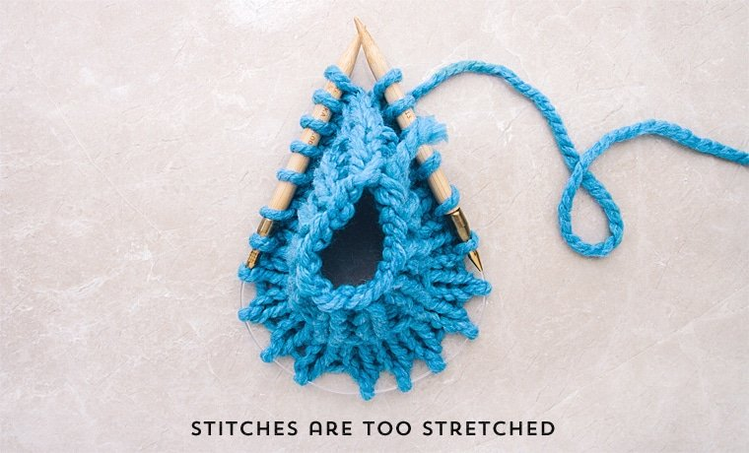
This circular needle is too large for the knitting. Notice the stretched stitches.
That doesn’t make for a fun knitting experience. You’ll also end up stretching out the hat before you’ve had a chance to wear it. It’s a lose-lose situation.

Key points:
- When knitting in the round, you’re always knitting on the front of the work. You never “turn” the needle to knit on the wrong side.
- Not needing to turn the work means knitting in the round is much faster than knitting flat
- Knitting in the round produces a seamless tube-like fabric
- When choosing a needle, the length of the needle should be shorter than the circumference of the knitting. (For example: use a 16 inch circular needle to knit a 20 inch hat).
- Bamboo and wooden needles have more surface drag and “grip” while steel needles are more smooth and slippery.
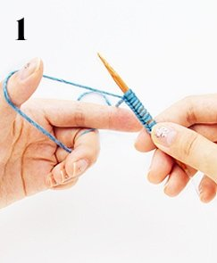
Cast on using your preferred method onto the circular needle

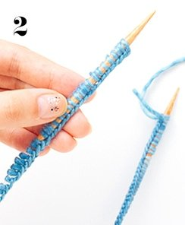
Notice the braided edge running along the entire length of the cast on.
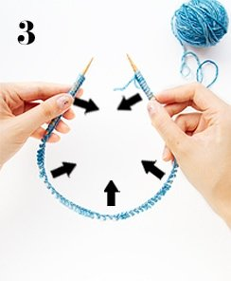
Turn the braided edge so that it’s facing the same direction. This will prevent the stitches from twisting.
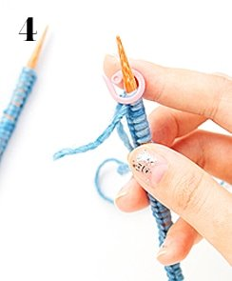
Make sure the working yarn is on the right needle. Place a stitch marker on the right needle.
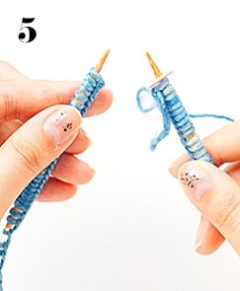
Get ready to knit by pushing the stitches close to the tips of the needles.

