Yarn Put Ups
The general term for the actual way yarn is presented (assuming it’s not in an unwound pile) is called, “put up”. Yarn can be put up in different ways.
Can you match the description with the pictures of the types of yarn put ups?
Fill in the picture letter, and see how many you know. Answers on the last page.
- Ball Answer:
- Cake Answer:
- Cone Answer:
- Donut Ball Answer:
- Hank Answer:
- Hard Core Ball Answer:
- Pull Skein Answer:
- Skein Answer:
Ball: a round ball, usually hand wound. You can knit from these easily, it does not collapse. Hand-winding can lead to stretching the yarn tightly into place that can affect your tension. Wind gently and wash your knitting after working from a ball to let the yarn bloom again.
Cake: it’s a ball of sorts. The yarn can be used from the center or from the side and it doesn’t roll around. You can knit directly from a cake.
Cone: yarn from cones are most often used by weavers. When yarn is wound onto a cone it undergoes a lot of pressure, stretching the yarn in place, so consider winding off into hanks, washing it, hanging the hanks to dry, then balling it and knitting from it.
Donut Ball: this is definitely different from a round ball. It’s used for packaging slippery luxury yarns that need to show off their loft and luster; yarns that come in smaller-yardage put-ups because they’re so precious.
Hank: a loop of yarn, fastened into a continuous circle with ties. Hanks are good for dyeing or painting yarn. Before you can knit with it, it needs to be wound into a ball or cake.
Hard Core Ball: is a ball wrapped over a rigid cardboard core, keeping it solid and presentable for display and storage. You will see fine cotton yarns, metallics, synthetics, and other yarns that tend to be slippery on these cardboard cores.
Pull Skein: this can also be called a center pull skein. You can knit directly off the store self- just remove the label and pull from the outside or the center and you are ready to go.
Skein: this is also called a twisted hank. The yarn is rolled into a loose, oblong-shaped twist. Skeins are typically measured in yards and meters, and weighed in ounces and grams.

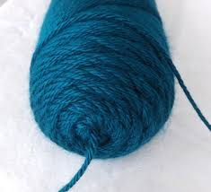
Picture A

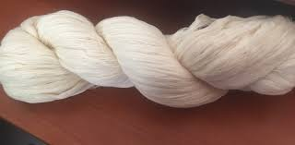
Picture C
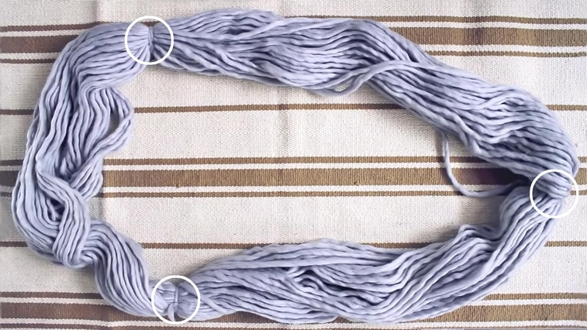
Picture E
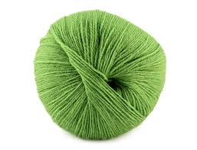
Picture G
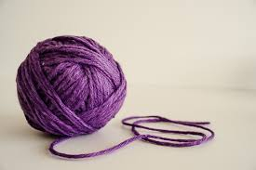
Picture B

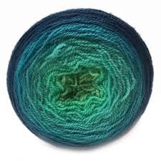
Picture D

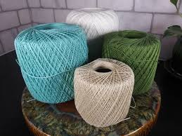
Picture F
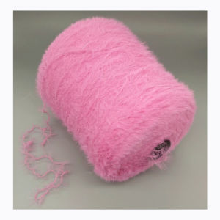
Picture H

Answers:
Ball = Picture B
Cake = Picture D
Cone = Picture H
Donut Ball = Picture G
Hank = Picture E
Hard Core Ball = Picture F
Pull Skein = Picture A
Skein = Picture C

